Pentest Blue-team CTF project


TestGoal
The goal is to find vulnerabilities in the flag submit webpage and the underlying systems.

Scope
The front-end and back-end machines of the CTF flag submit system are in scope; everything else is out of scope. DOS and DDOS attacks or brute forcing the submit form are out of scope as well.

Findings
The front-end and back-end were both running up-to-date software with only the essential ports open and proved to have no direct attack surface. The web page for submitting the flag consisted of just one accessible web page with a submit form field for the flag. XSS and SQLI didn’t work at all because the fields were correctly sanitized. When using Burpsuite I was able to intercept the response of the server and found out that the real flag was being sent back in the response only it was encrypted with bcrypt with its salt. I was also able to trick the front-end by changing the response field which indicated if the flag was correct from invalid to valid. Thus the front-end accepted my bogus flag and I could continue to the next pages collecting all the real flags from the responses as I went on.

Flag 1: $2a$12$XMRBKHnP6YBPrQEea5TEauZ9BkVRiDHEGAgf42XHxhmwUMD2j0ri6
Flag 2: $2a$12$9s7jF.9sziKVLH9OYBIPQuG9v.8t/nVgM41PZ2P1CXYryhYkdR3QC
Flag 3: $2a$12$7pdzSQNS/CihEa/WcRstPuonCYVAbwocmc37kpAFKvdxNFvaQ6oUG
Flag 4: $2a$12$ZX5SPzGnAh.UKV05SzjWAe6fDrNSTkyLlANwskrevG0pwj6i/Zk6u
Flag 5: $2a$12$xO.UzF3PAYEQCgAhb7F16urYHUsQQX2UPEZJyeXdWdKZ.xw3TOEQG
Flag 6: $2a$12$E8WoioPSyNE8p854LKOVAe4.TtoTZEInTIziLSNO.oZsnGZQ42Tce

Meaning
This was an exploit in the front-end which isn’t an impact or threat to their core systems or network. The hashes of the real flags can’t be submitted like this and have to be cracked first. With a powerful cracking machine someone might be able to crack them fast enough to cheat the system.

Conclusion
Conclusion, the exploit isn’t a threat to the production environment and is unlikely to be an issue during the CTF to cheat the system. Just to be sure it is advisable to prevent the hash of being in the response back to the front-end. Also some more front-end validation would be recommended to at least try to mitigate the front-end validation bug.

Tests and test results
First a nmap scan of the front-end was performed:

# Nmap 7.92 scan initiated Mon Nov 22 11:59:54 2021 as: nmap -A -v -sS -p 1-50000 -oN frontScan.xml 172.16.1.17
Nmap scan report for 172.16.1.17
Host is up (0.0072s latency).
Not shown: 49998 filtered tcp ports (no-response)
PORT STATE SERVICE VERSION
22/tcp open ssh OpenSSH 8.2p1 Ubuntu 4ubuntu0.2 (Ubuntu Linux; protocol 2.0)
| ssh-hostkey:
| 3072 84:10:b4:f1:78:c8:d3:3d:27:78:e3:2e:92:52:c6:ca (RSA)
| 256 67:9b:9e:45:0f:ec:ee:6b:5d:1f:11:e1:48:7c:db:2b (ECDSA)
|_ 256 c3:68:ea:73:a6:67:98:40:16:84:2f:f0:c8:7b:34:f8 (ED25519)
80/tcp open http Apache httpd 2.4.41 ((Ubuntu))
|_http-server-header: Apache/2.4.41 (Ubuntu)
|_http-title: 403 Forbidden
Warning: OSScan results may be unreliable because we could not find at least 1 open and 1 closed port
Device type: general purpose
Running (JUST GUESSING): Linux 4.X|5.X (85%)
OS CPE: cpe:/o:linux:linux_kernel:4 cpe:/o:linux:linux_kernel:5
Aggressive OS guesses: Linux 4.15 - 5.6 (85%)
No exact OS matches for host (test conditions non-ideal).
Uptime guess: 43.710 days (since Sat Oct 9 19:59:00 2021)
Network Distance: 2 hops
TCP Sequence Prediction: Difficulty=258 (Good luck!)
IP ID Sequence Generation: All zeros
Service Info: OS: Linux; CPE: cpe:/o:linux:linux_kernel

TRACEROUTE (using port 22/tcp)
HOP RTT ADDRESS
1 8.26 ms 172.16.50.1
2 8.32 ms 172.16.1.17

Read data files from: /usr/bin/../share/nmap
OS and Service detection performed. Please report any incorrect results at https://nmap.org/submit/ .
# Nmap done at Mon Nov 22 12:01:31 2021 -- 1 IP address (1 host up) scanned in 97.30 seconds

Then a nmap scan of the back-end:

# Nmap 7.92 scan initiated Mon Nov 22 11:44:22 2021 as: nmap -A -v -sS -p 1-50000 -oN backendScan.xml 172.16.1.19
Nmap scan report for 172.16.1.19
Host is up (0.0042s latency).
Not shown: 49998 filtered tcp ports (no-response)
PORT STATE SERVICE VERSION
22/tcp open ssh OpenSSH 8.2p1 Ubuntu 4ubuntu0.3 (Ubuntu Linux; protocol 2.0)
| ssh-hostkey:
| 3072 39:e9:ca:de:33:02:30:93:22:cb:ec:6f:1a:00:09:36 (RSA)
| 256 71:f9:69:c3:c0:8d:60:d8:6f:ad:bd:bc:a7:0d:87:05 (ECDSA)
|_ 256 d2:f9:27:d6:c7:63:79:e8:8c:88:b2:19:56:ab:0d:21 (ED25519)
5000/tcp open http Apache httpd 2.4.41 ((Ubuntu))
|_http-title: 403 Forbidden
|_http-server-header: Apache/2.4.41 (Ubuntu)
Warning: OSScan results may be unreliable because we could not find at least 1 open and 1 closed port
Device type: general purpose
Running (JUST GUESSING): Linux 4.X|5.X (85%)
OS CPE: cpe:/o:linux:linux_kernel:4 cpe:/o:linux:linux_kernel:5
Aggressive OS guesses: Linux 4.15 - 5.6 (85%)
No exact OS matches for host (test conditions non-ideal).
Uptime guess: 34.711 days (since Mon Oct 18 19:42:32 2021)
Network Distance: 2 hops
TCP Sequence Prediction: Difficulty=258 (Good luck!)
IP ID Sequence Generation: All zeros
Service Info: OS: Linux; CPE: cpe:/o:linux:linux_kernel

TRACEROUTE (using port 22/tcp)
HOP RTT ADDRESS
1 4.47 ms 172.16.50.1
2 4.52 ms 172.16.1.19

Read data files from: /usr/bin/../share/nmap
OS and Service detection performed. Please report any incorrect results at https://nmap.org/submit/ .
# Nmap done at Mon Nov 22 11:46:39 2021 -- 1 IP address (1 host up) scanned in 137.19 seconds

The scans didn’t find anything useful or more to go after. So a dirbuster scan was performed to check for hidden directories or pages on the front-end:

-----------------
DIRB v2.22
By The Dark Raver
-----------------

OUTPUT_FILE: dirbScan.txt
START_TIME: Mon Nov 22 11:45:08 2021
URL_BASE: http://172.16.1.17/
WORDLIST_FILES: /usr/share/wordlists/dirb/big.txt

-----------------

GENERATED WORDS: 20458

---- Scanning URL: http://172.16.1.17/ ----
+ http://172.16.1.17/Thumbs.db (CODE:403|SIZE:276)
+ http://172.16.1.17/favicon.ico (CODE:200|SIZE:3585)
==> DIRECTORY: http://172.16.1.17/img/
+ http://172.16.1.17/robots.txt (CODE:200|SIZE:67)
+ http://172.16.1.17/server-status (CODE:403|SIZE:276)
==> DIRECTORY: http://172.16.1.17/static/

---- Entering directory: http://172.16.1.17/img/ ----
+ http://172.16.1.17/img/Thumbs.db (CODE:403|SIZE:276)

---- Entering directory: http://172.16.1.17/static/ ----
+ http://172.16.1.17/static/Thumbs.db (CODE:403|SIZE:276)
==> DIRECTORY: http://172.16.1.17/static/css/
==> DIRECTORY: http://172.16.1.17/static/js/

---- Entering directory: http://172.16.1.17/static/css/ ----
+ http://172.16.1.17/static/css/Thumbs.db (CODE:403|SIZE:276)

---- Entering directory: http://172.16.1.17/static/js/ ----
+ http://172.16.1.17/static/js/Thumbs.db (CODE:403|SIZE:276)

-----------------
END_TIME: Mon Nov 22 11:56:27 2021
DOWNLOADED: 102290 - FOUND: 8

This also didn’t give any useful results to pursue.

Next I used Burpsuite to look at the request that was made to the backend when submitting a flag.

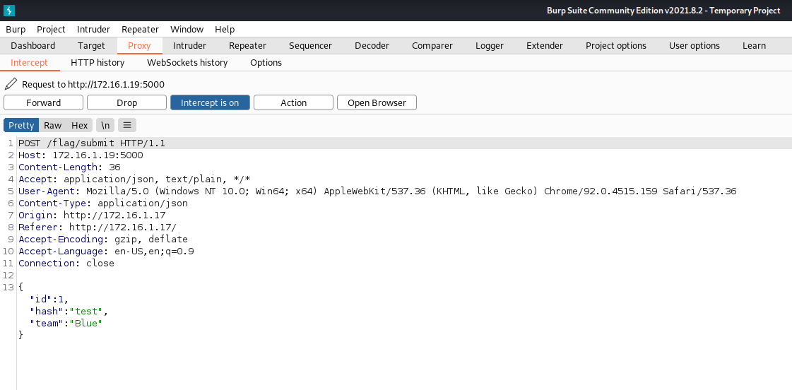

It appeared to be normal. It was just sending the flag labeled as hash to the backend and a team for which I couldn’t find the purpose but changing it to something else didn’t seem to do anything. So next I tried intercepting the response from the server for this request.

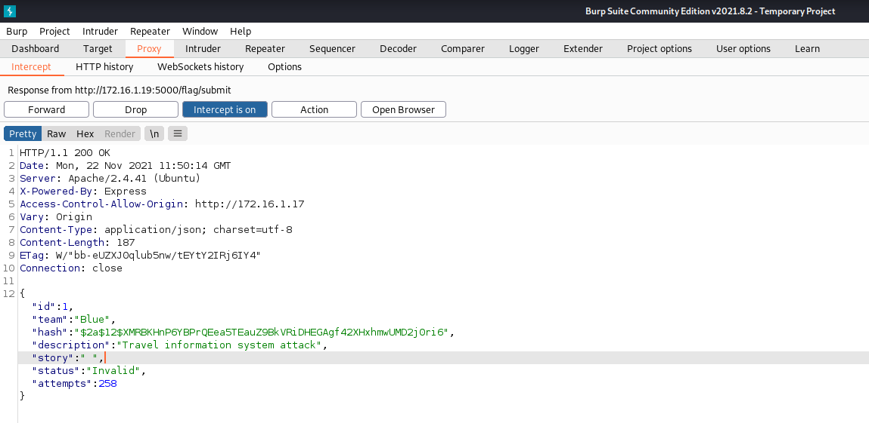
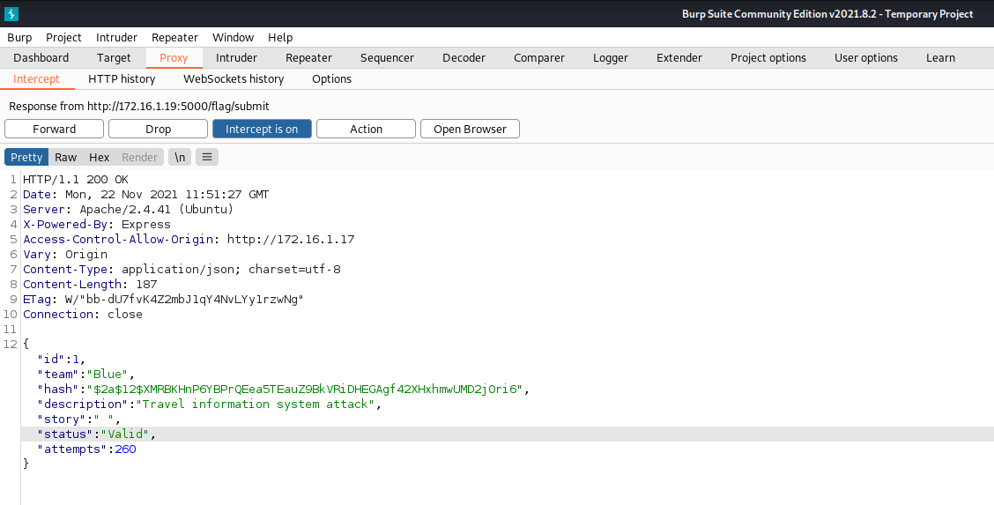

It looks like they actually send the real flag back to me but it’s hashed. They also added a status element which I can change to valid to trick the front-end validation.

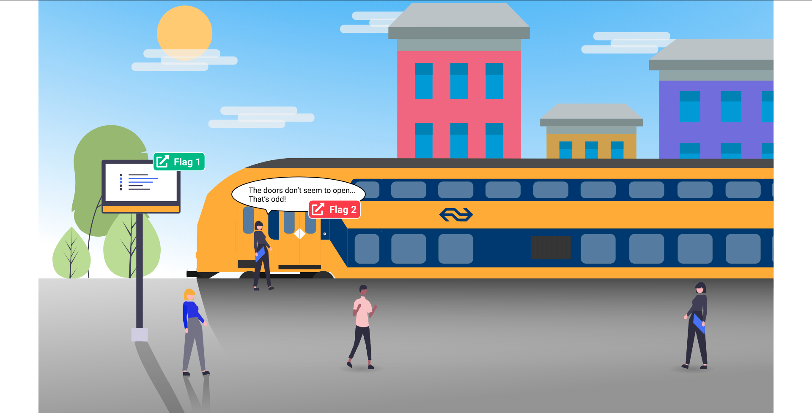

When changing the value from invalid to valid I was able to continue to the next flag and this trick worked for every flag submit form giving me all the flag hashes in the end.

Flag 1: $2a$12$XMRBKHnP6YBPrQEea5TEauZ9BkVRiDHEGAgf42XHxhmwUMD2j0ri6
Flag 2: $2a$12$9s7jF.9sziKVLH9OYBIPQuG9v.8t/nVgM41PZ2P1CXYryhYkdR3QC
Flag 3: $2a$12$7pdzSQNS/CihEa/WcRstPuonCYVAbwocmc37kpAFKvdxNFvaQ6oUG
Flag 4: $2a$12$ZX5SPzGnAh.UKV05SzjWAe6fDrNSTkyLlANwskrevG0pwj6i/Zk6u
Flag 5: $2a$12$xO.UzF3PAYEQCgAhb7F16urYHUsQQX2UPEZJyeXdWdKZ.xw3TOEQG
Flag 6: $2a$12$E8WoioPSyNE8p854LKOVAe4.TtoTZEInTIziLSNO.oZsnGZQ42Tce

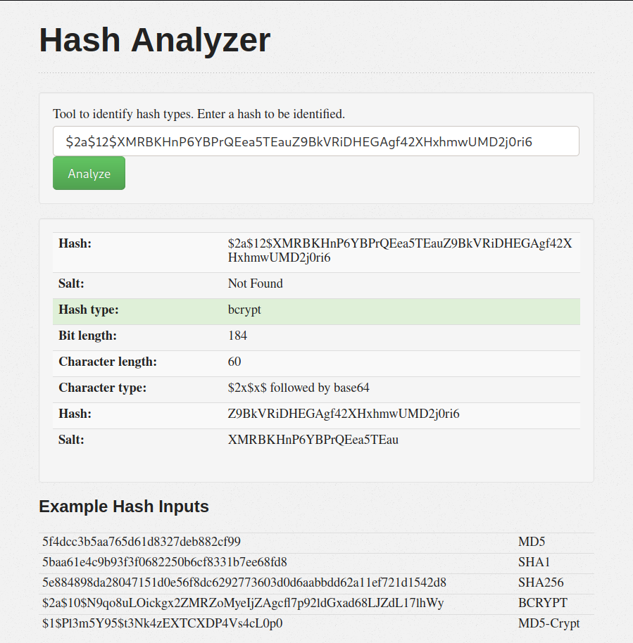
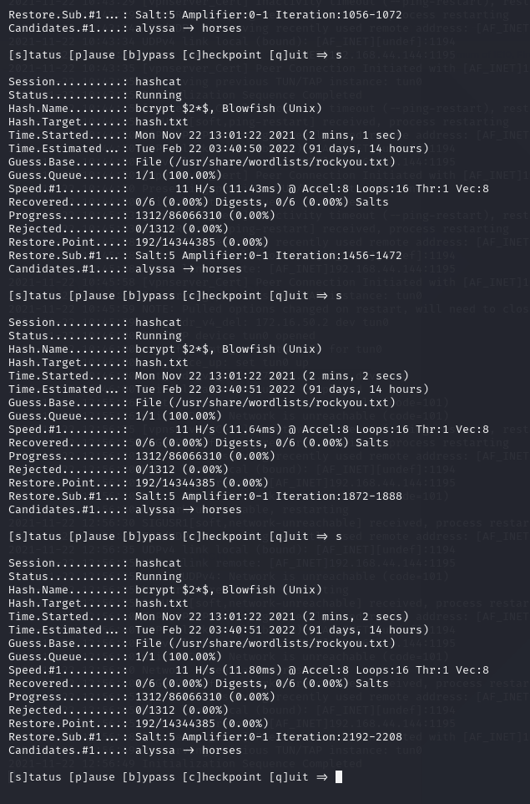

Passing the hashes through hashcat showed me that it is unlikely to crack the hashes in time to be anything useful in cheating in the CTF. It would just take way too long.

